Question no 1

Code
#include <stdio.h>
#include <pthread.h>
#include <semaphore.h>
#include <unistd.h>
sem_t mutex; // Binary semaphore
int counter = 0;
void *thread_function(void *arg)
{
int id = *(int *)arg;
for (int i = 0; i < 5; i++)
{
printf("Thread %d: Waiting...\n", id);
sem_wait(&mutex); // Acquire
// Critical section
counter++;
printf("Thread %d: In critical section | Counter = %d\n", id,
counter);
sleep(1);
sem_post(&mutex); // Release
sleep(1);
}
return NULL;
}
int main()
{
sem_init(&mutex, 0, 1); // Binary semaphore initialized to 1
pthread_t t1, t2;
int id1 = 1, id2 = 2;
pthread_create(&t1, NULL, thread_function, &id1);
pthread_create(&t2, NULL, thread_function, &id2);
pthread_join(t1, NULL);
pthread_join(t2, NULL);
printf("Final Counter Value: %d\n", counter);
sem_destroy(&mutex);
return 0;
}

Output

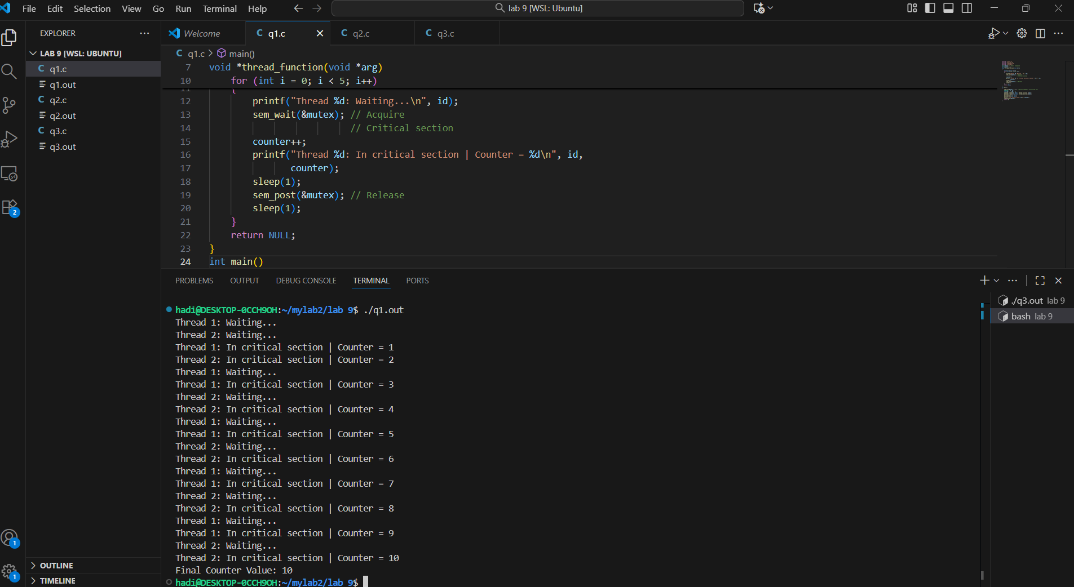

Question no 2

Code
#include <stdio.h>
#include <pthread.h>
#include <unistd.h>
int turn;
int flag[2] = {0, 0};
int counter = 0; // Shared resource
void *process(void *arg)
{
int id = *(int *)arg;
int other = 1 - id;
// Thread ID: 0 or 1
for (int i = 0; i < 5; i++)
{
// Entry section
flag[id] = 1;
turn = other;
while (flag[other] && turn == other)
;
// Critical section
counter++;
printf("Thread %d in critical section | Counter = %d\n", id,
counter);
sleep(1);
// Exit section
flag[id] = 0;
sleep(1);
}
return NULL;
}
int main()
{

pthread_t t1, t2;
int id1 = 0, id2 = 1;
pthread_create(&t1, NULL, process, &id1);
pthread_create(&t2, NULL, process, &id2);
pthread_join(t1, NULL);
pthread_join(t2, NULL);
printf("Final Counter Value: %d\n", counter);
return 0;

}

Ouput

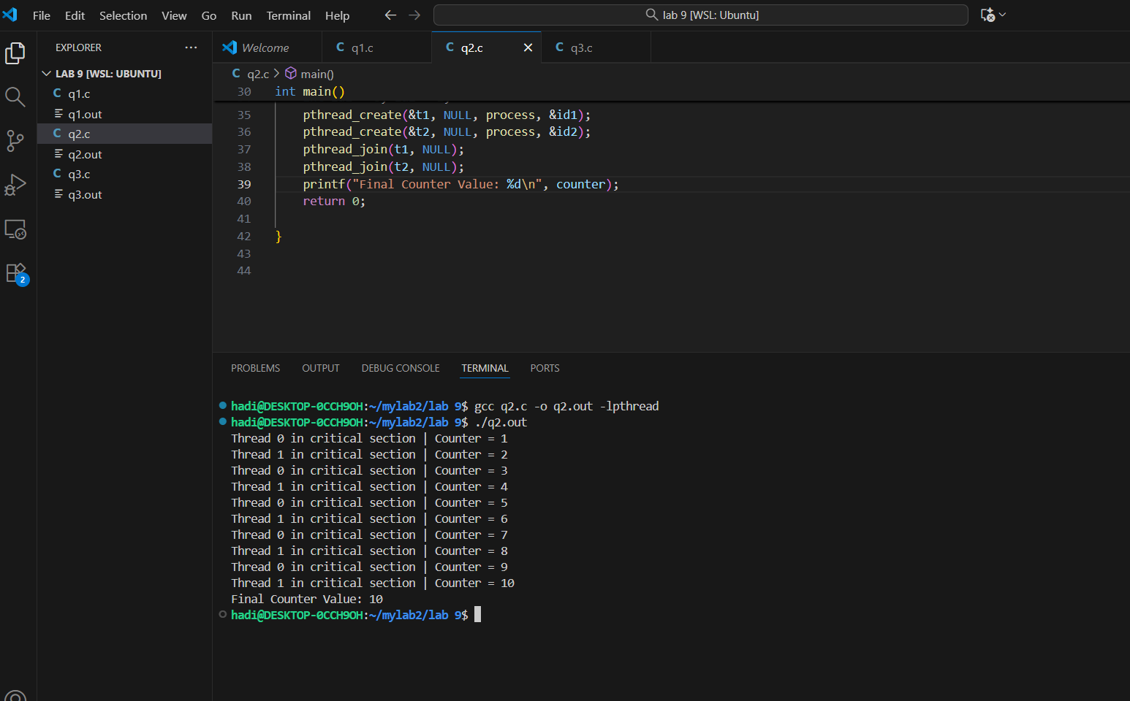

Question n 3

#include <stdio.h>
#include <pthread.h>
#include <semaphore.h>
#include <unistd.h>
sem_t mutex; // Binary semaphore
int counter = 0;
void* thread_function(void* arg) {
int id = *(int*)arg;
for (int i = 0; i < 5; i++) {
printf("Thread %d: Waiting...\n", id);
sem_wait(&mutex); // Acquire
// Critical section
counter++;
printf("Thread %d: In critical section | Counter = %d\n", id,
counter);
sleep(1);
sem_post(&mutex); // Release
sleep(1);
}
return NULL;
}
int main() {
sem_init(&mutex, 0, 1); // Binary semaphore initialized to 1
pthread_t t1, t2;
int id1 = 1, id2 = 2;
pthread_create(&t1, NULL, thread_function, &id1);
pthread_create(&t2, NULL, thread_function, &id2);
pthread_join(t1, NULL);
pthread_join(t2, NULL);
printf("Final Counter Value: %d\n", counter);
sem_destroy(&mutex);
return 0;
}
Output

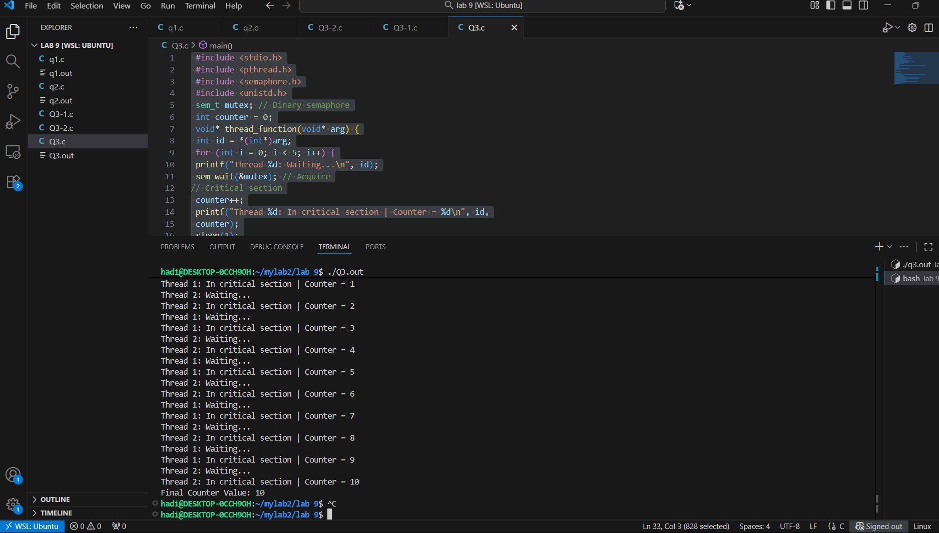

Question no 3-1
Code
#include <stdio.h>
#include <pthread.h>
#include <semaphore.h>
#include <unistd.h>
sem_t mutex; // Binary semaphore
int counter = 0;
void* thread_function(void* arg) {
int id = *(int*)arg;
for (int i = 0; i < 5; i++) {
printf("Thread %d: Waiting...\n", id);
sem_wait(&mutex); // Acquire
// Critical section
counter++;
printf("Thread %d: In critical section | Counter = %d\n", id,
counter);
sleep(1);
sem_post(&mutex); // Release
sleep(1);
}
return NULL;
}
int main() {
sem_init(&mutex, 0, 0); // Binary semaphore initialized to 1
pthread_t t1, t2;
int id1 = 1, id2 = 2;
pthread_create(&t1, NULL, thread_function, &id1);
pthread_create(&t2, NULL, thread_function, &id2);
pthread_join(t1, NULL);
pthread_join(t2, NULL);
printf("Final Counter Value: %d\n", counter);
sem_destroy(&mutex);
return 0;
}

Output

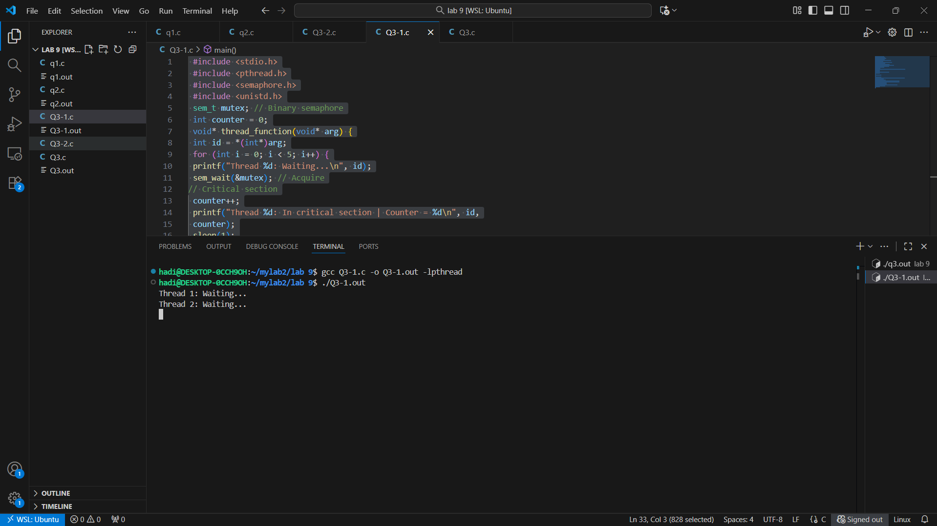

Question no 3-2

Code
#include <stdio.h>
#include <pthread.h>
#include <semaphore.h>
#include <unistd.h>
sem_t mutex; // Binary semaphore
int counter = 0;
void* thread_function(void* arg) {
int id = *(int*)arg;
for (int i = 0; i < 100000; i++) {
// printf("Thread %d: Waiting...\n", id);
// sem_wait(&mutex); // Acquire
// Critical section
counter++;
printf("Thread %d: In critical section | Counter = %d\n", id,
counter);
// sleep(1);
sem_post(&mutex); // Release
// sleep(1);
}
return NULL;
}
int main() {
sem_init(&mutex, 0, 1); // Binary semaphore initialized to 1
pthread_t t1, t2;
int id1 = 1, id2 = 2;
pthread_create(&t1, NULL, thread_function, &id1);
pthread_create(&t2, NULL, thread_function, &id2);
pthread_join(t1, NULL);
pthread_join(t2, NULL);
printf("Final Counter Value: %d\n", counter);
sem_destroy(&mutex);
return 0;
}
Output
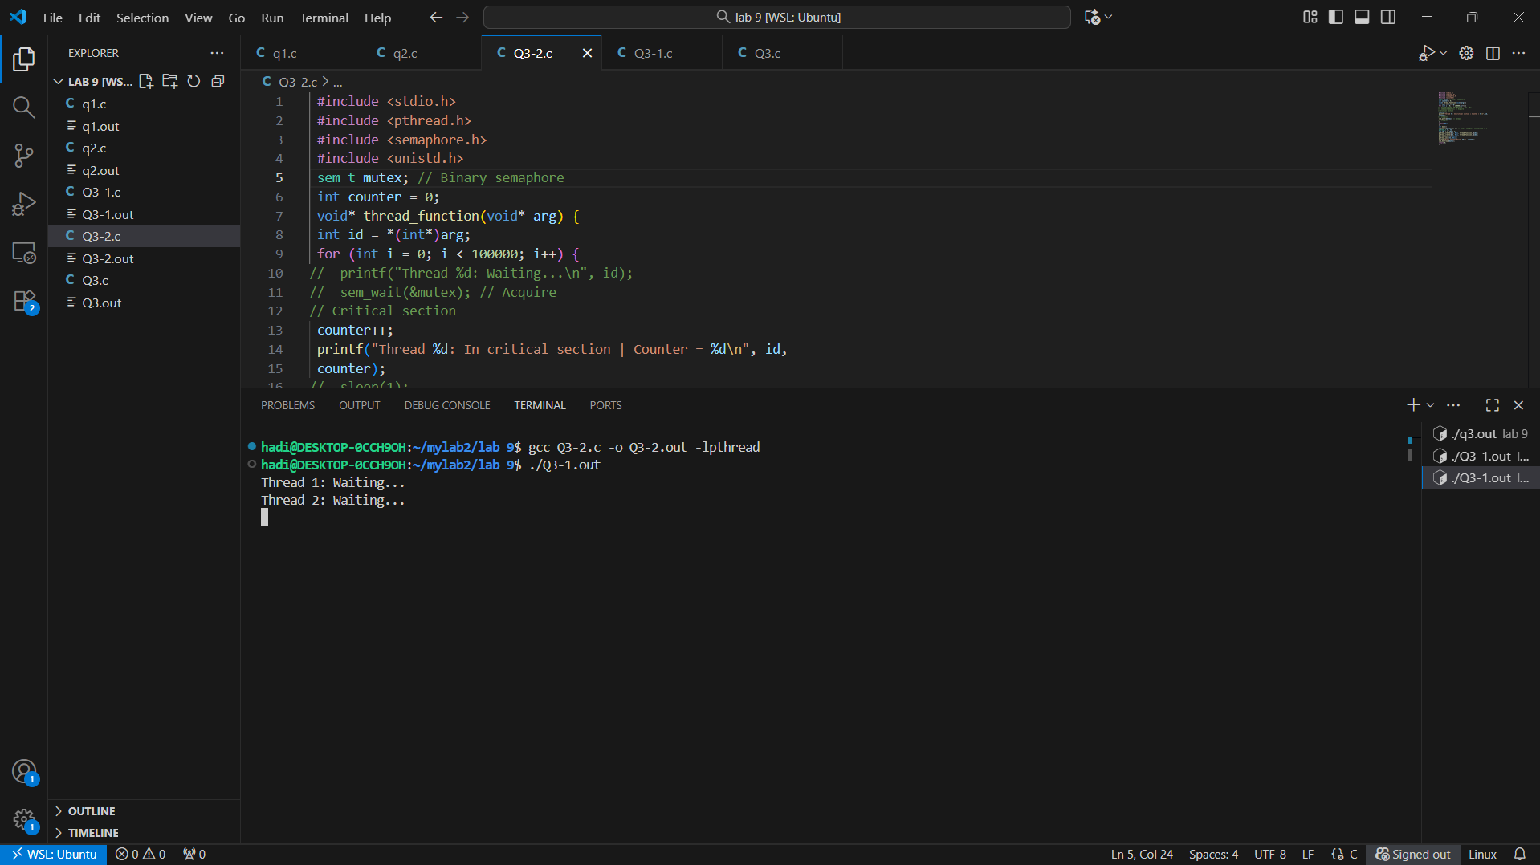

A mutex is just a lock. Only one thread can lock it, and only that same thread is allowed to unlock it. It is used only to stop two threads from entering the critical section at the same time.
A semaphore is a signaling tool. Its value can be 0, 1, or more. Any thread can increase (signal) it, and it can be used both for mutual exclusion and for sending signals between threads.

